Project 3 Phase 1

Caleb Burke

Hello_world Custom Logic synthesis and deployment with HDK and ASS EC2 F1 instances

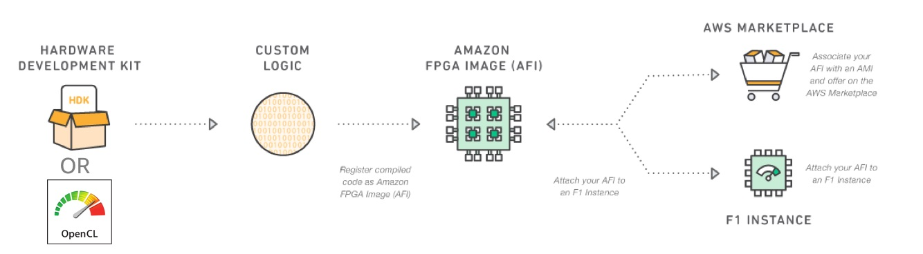

From github

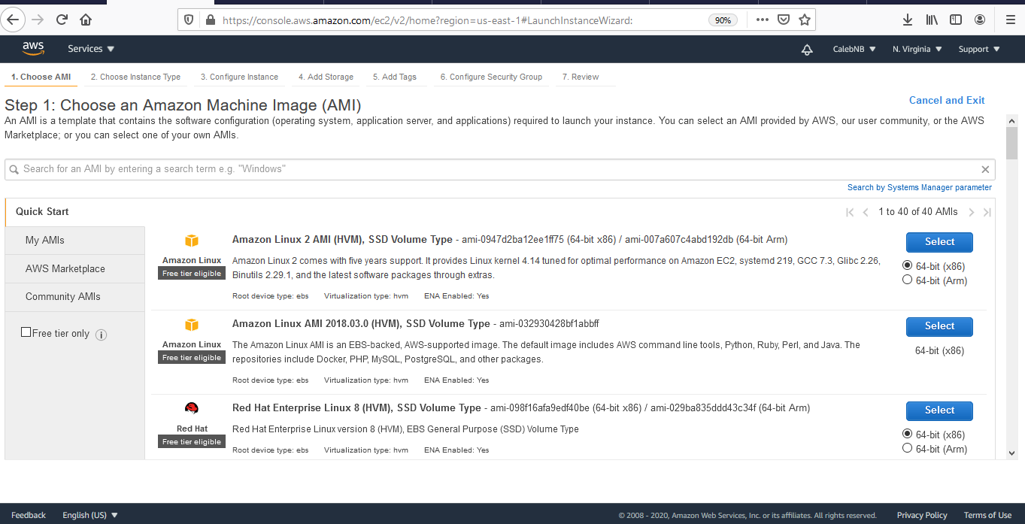

Choose Image

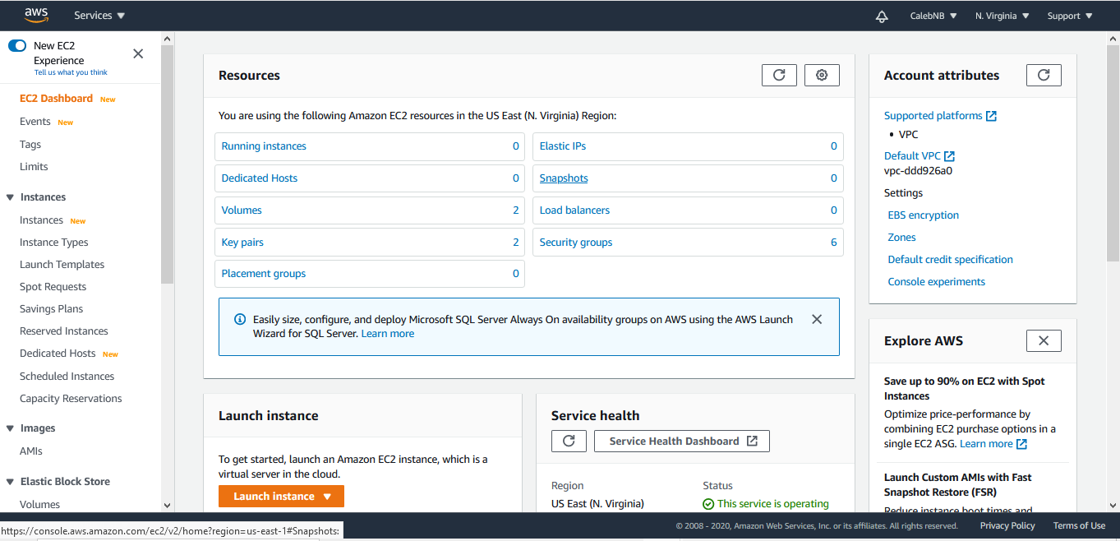

Launch Instance

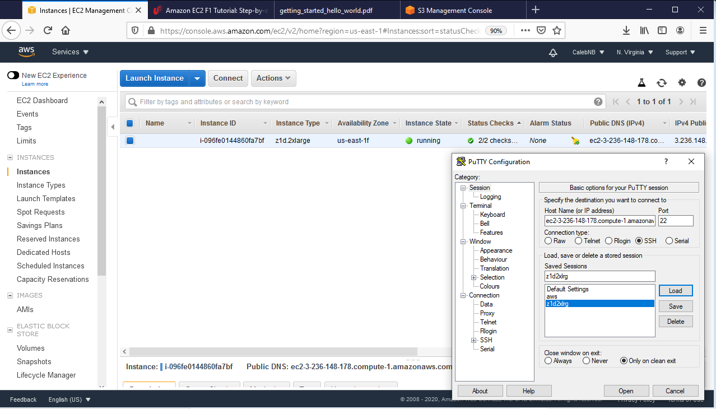

Connect to Instance

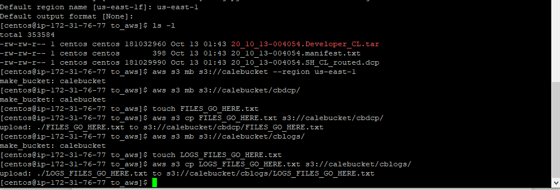

Make S3 bucket

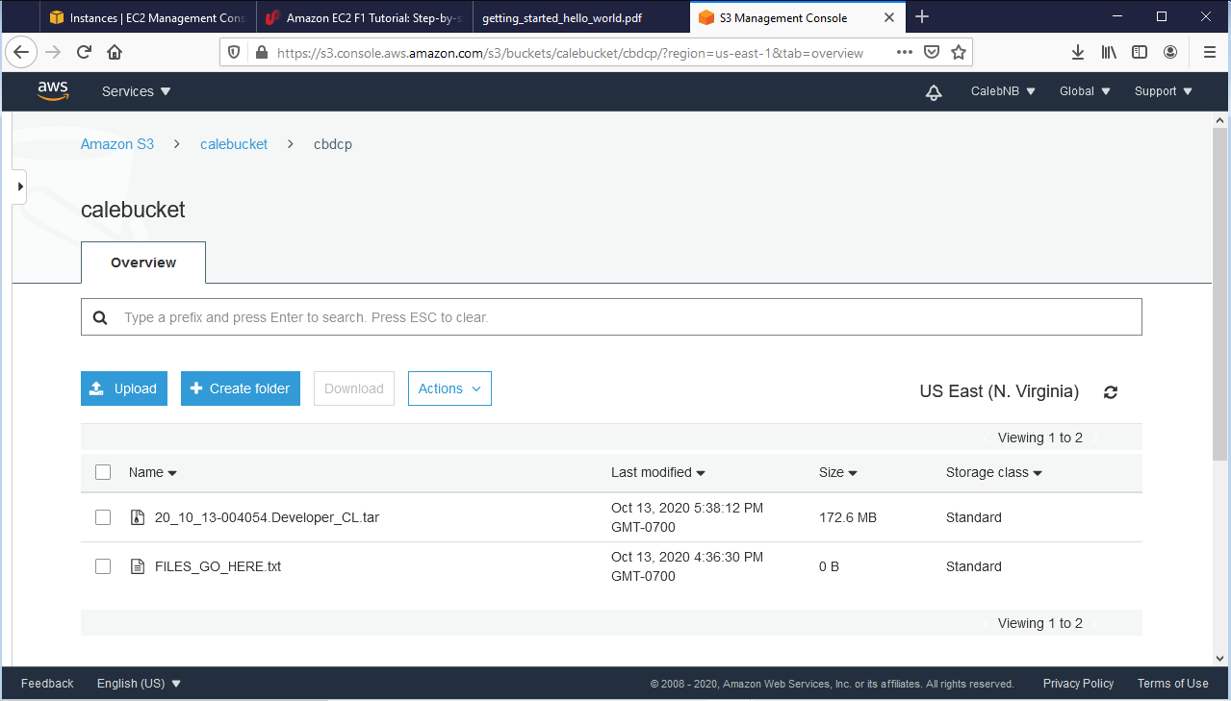

S3 bucket dcp s3 console

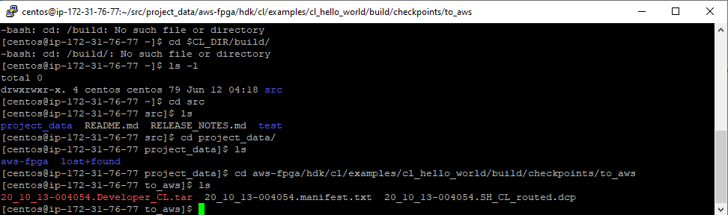

Successful synthesis CL

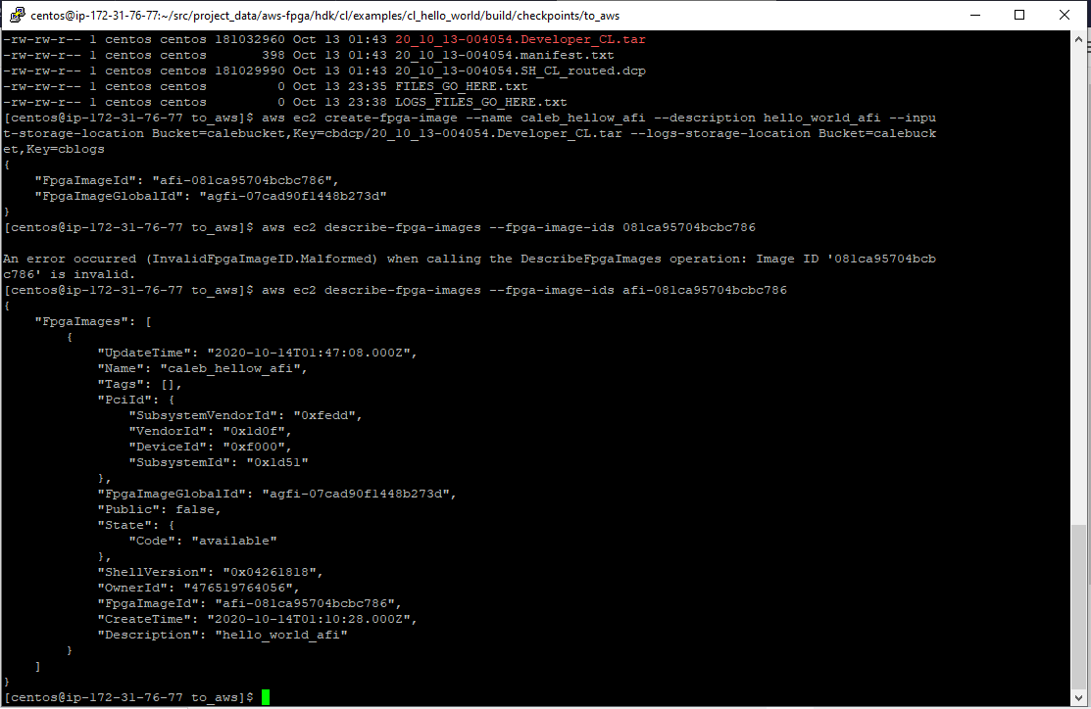

Describe fpga images

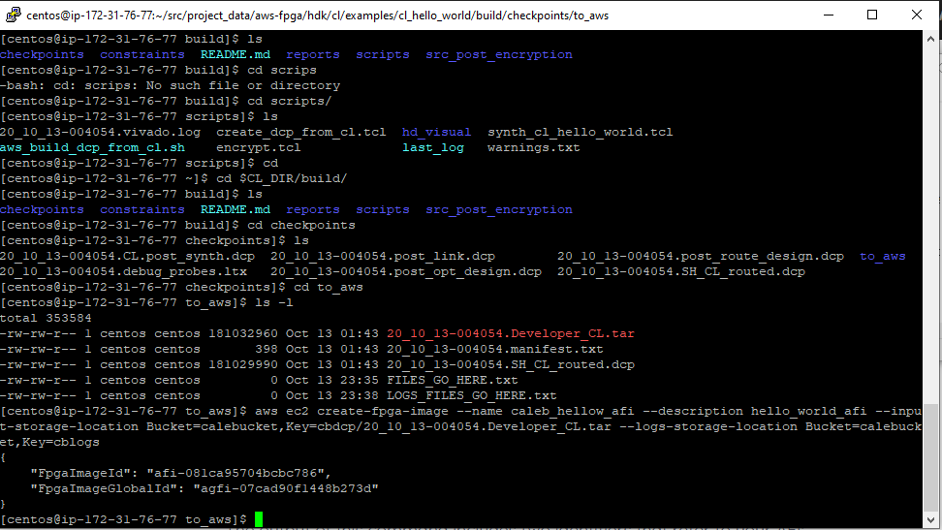

Create AFI

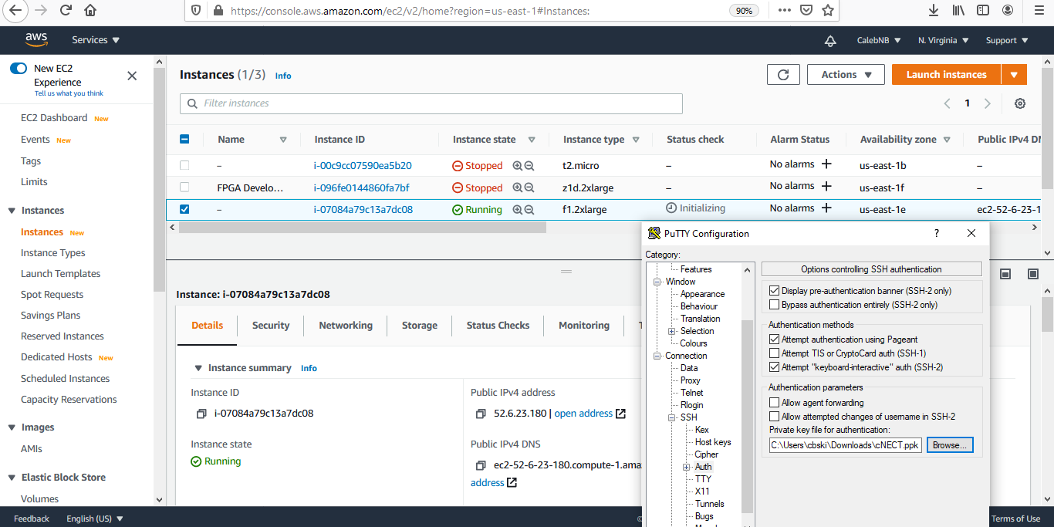

Connect to F1 instance

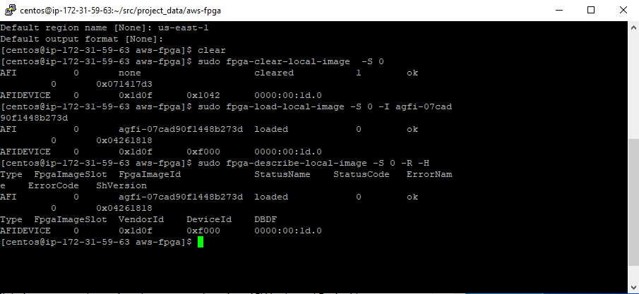

Clear, load, and verify fpga

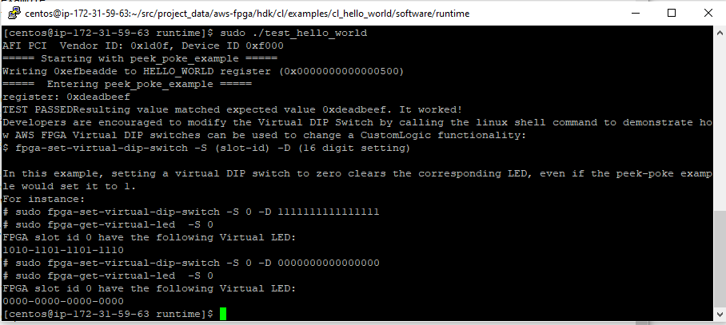

Test Hello World.